

**Submitted by: Submitted to:**

**NAME: Rahul Gusain Hitesh Kumar Sharma**   
 **SAP: 500084143**  
 **ROLL NO.: R214220900**  
 **BATCH: 1 DevOps**

EXPERIMENT 2

**AIM: Working with Docker (Basic Commands)**

**Steps to Complete:**

1. Search a Redis image on DockerHub

**Command:** docker search redis

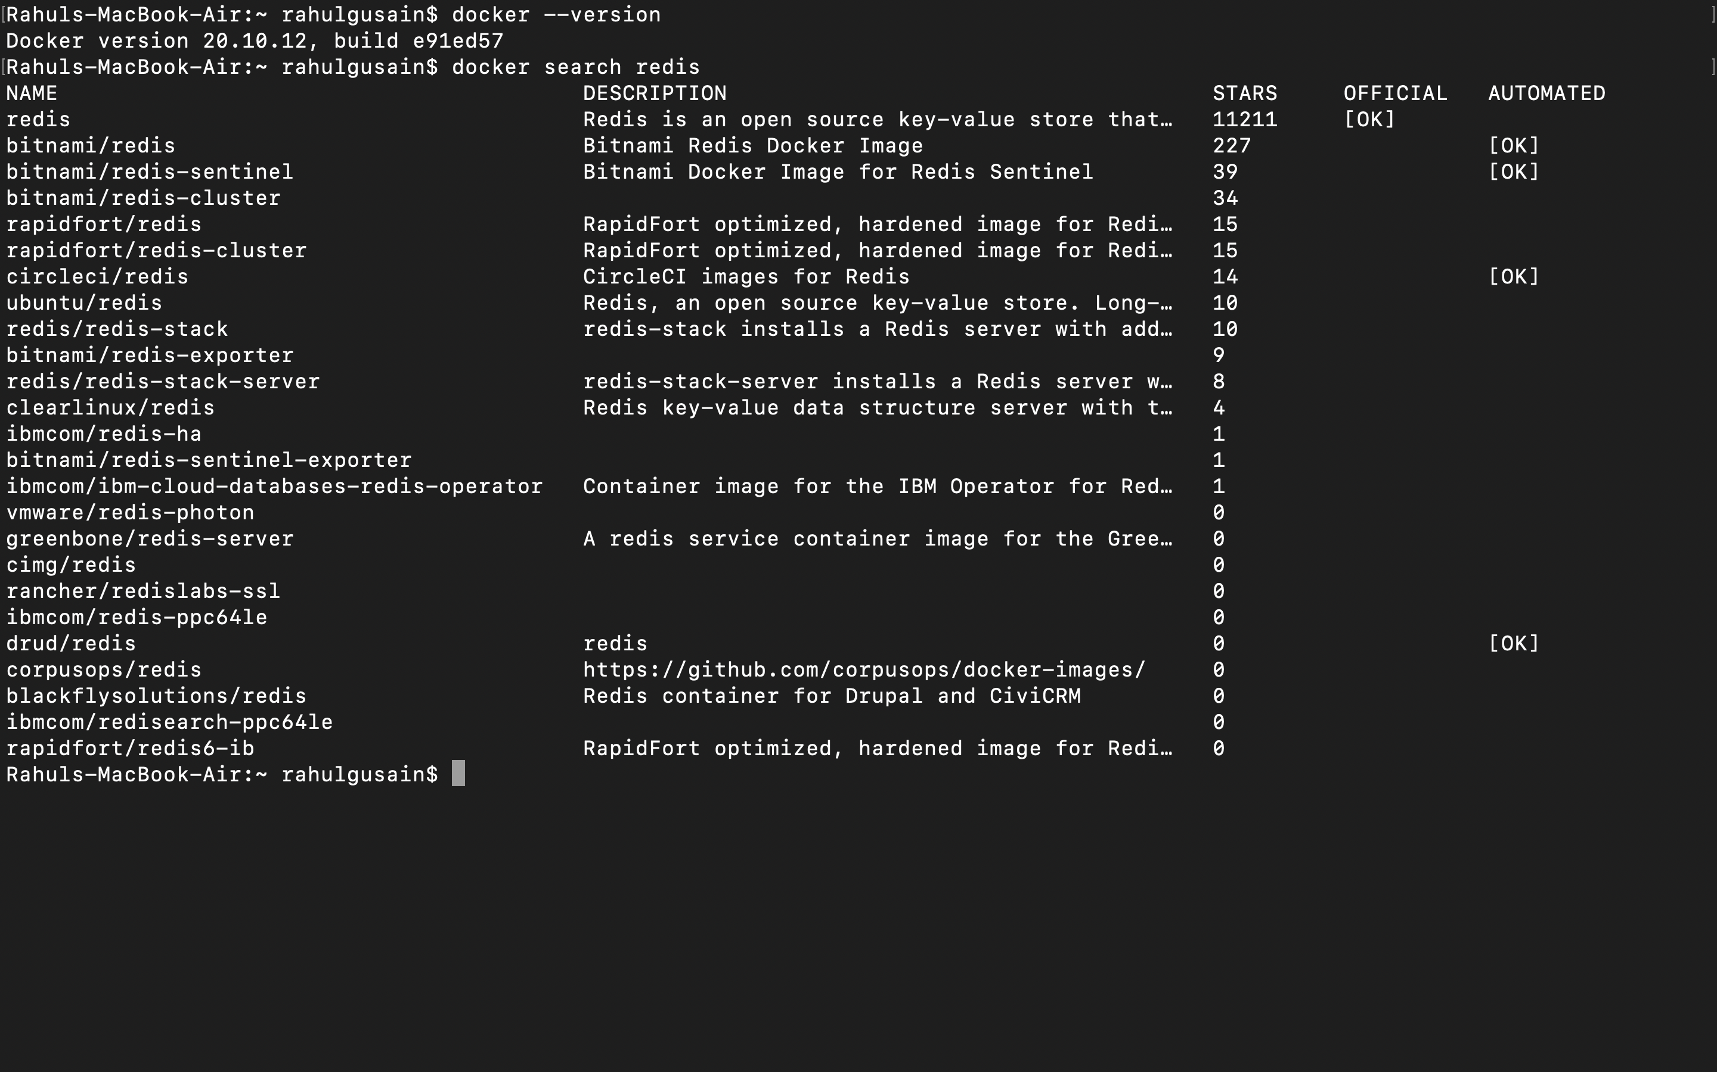

2. Run Docker Container of Redis Image in background

**Command:** docker run -d redis

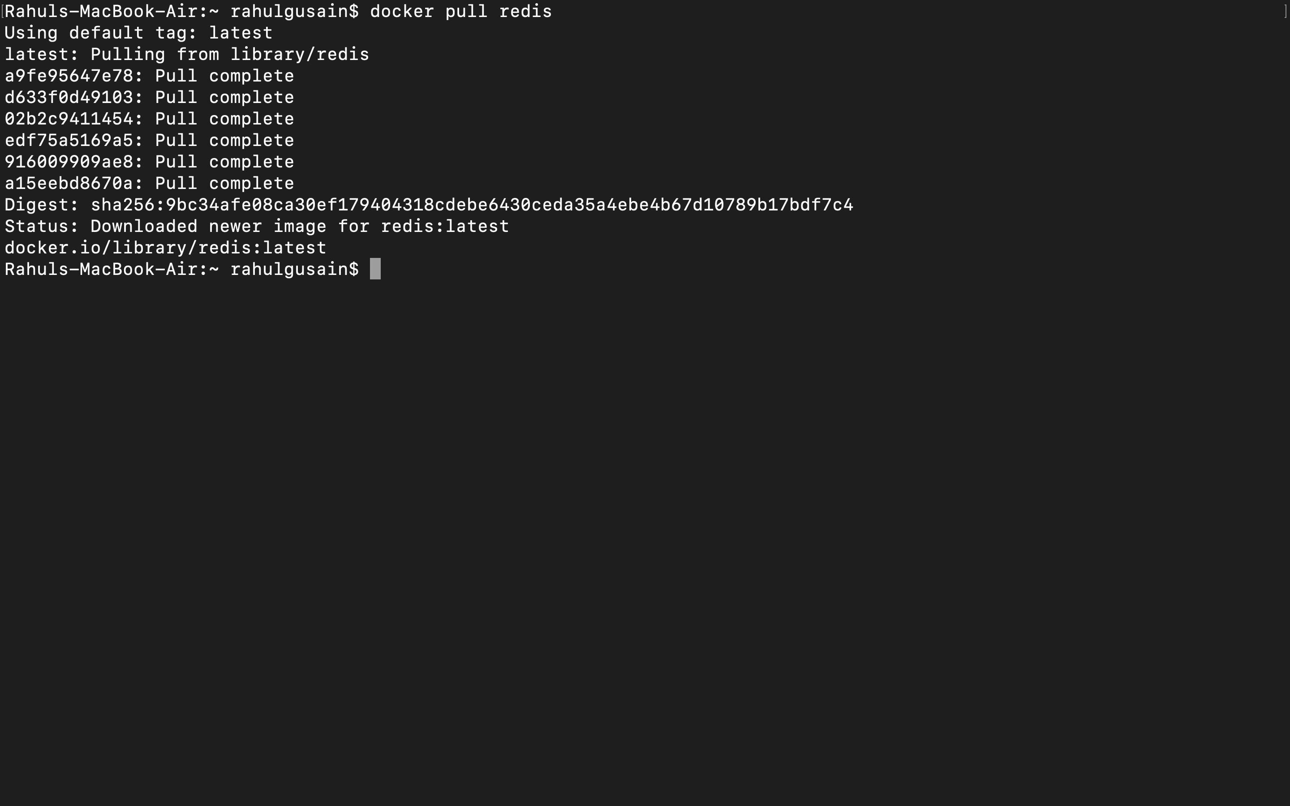

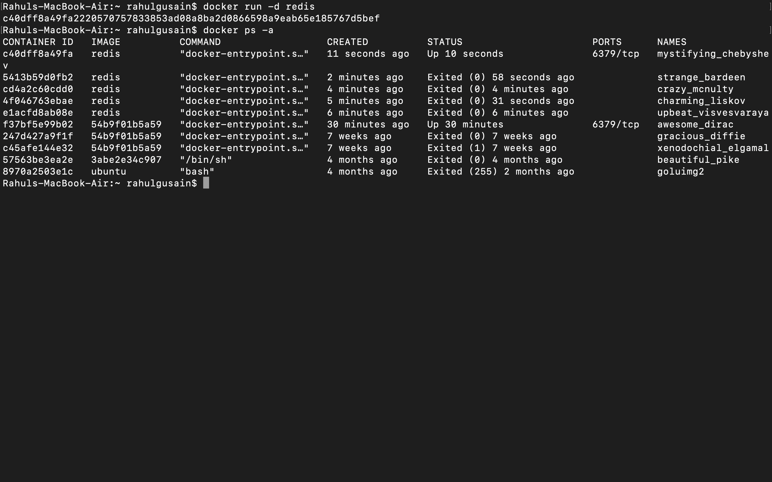

3. Run Docker PS and Docker PS –a

**Command:** docker ps

docker ps -a

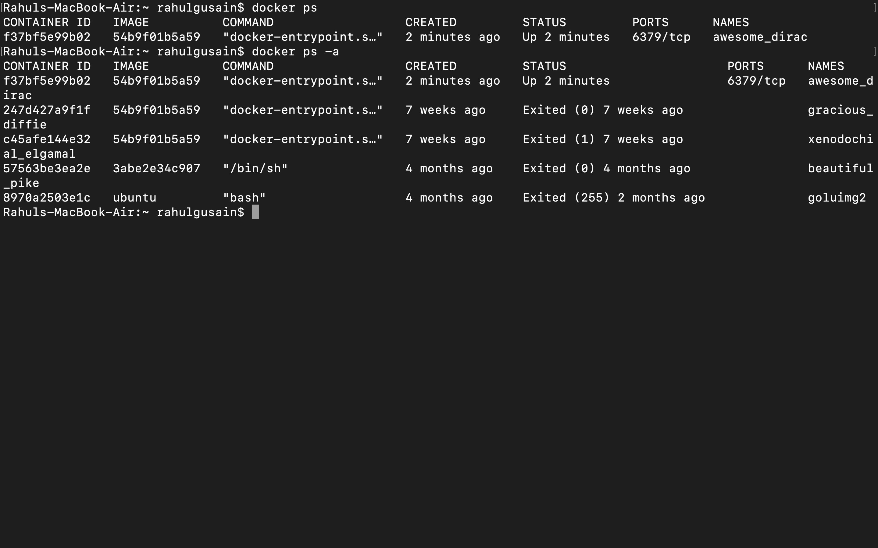

4. Run Docker Container and take its console

**Command:** docker run –it redis /bin/bash

ls  
 exit

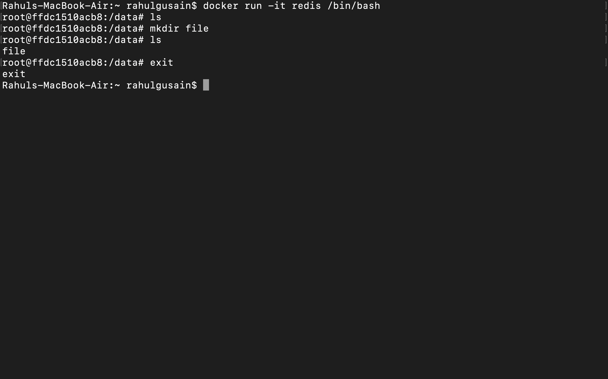  
 5. Create a Docker Volume and connect it

**Command:**odocker run -it -v myvol:/data redis /bin/bash

